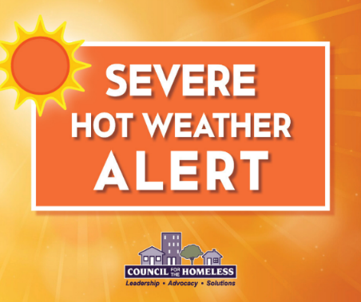
Severe Weather Alert
Friday through Tuesday
June 14-16, 2026

Clark County, Wash. (June 12, 2026) — Council for the Homeless is issuing a Severe Weather Alert for the emergency shelter system in Clark County, beginning Sunday, June 14, 2026 through the evening of Tuesday, June 16, 2026. Additional resources and increased shelter capacity will be activated during this time.

DAYTIME COOLING CENTERS:

Live Love at Living Hope Church
Days open: Sunday and Monday
Hours: 1:30 PM - 7:00 PM
Pets in kennels are allowed.
Address: 2711 NE Andresen Road, Vancouver 98661
Closest Bus Stop: Andresen and Fourth Plain

Mill Plain United Methodist Church
Days open: Monday and Tuesday
Hours: 2:00 PM - 8:00 PM
Address: 15804 SE Mill Plain Blvd, Vancouver 98684
Pets are welcome as long as they are on a leash or in a kennel.
Closest Bus Stop: Mill Plain and 157th

DAYTIME MISTING STATIONS:

The Couve Collective (parking lot)
Days open: Saturday through Monday
Hours: 1:00 PM – 6:00 PM
Pers are welcome with a splash pad just for them
Address: 1009 W 13th St, Vancouver, WA 98660

Outpost Safe Stay Misting station will be outside of the gate
Days open: Saturday though Tuesday
Hours: 2:00 PM – 6:00 PM
Address: 11400 NE 51st Cir, Vancouver, WA 98682
Pets on leash are welcome on a good-behavior basis
C-tran #80 line Stop IDs
0936 NE 112th Ave & 51st Cir (Southbound)
6184 NE 51st Cir & 112th Ave (Westbound)

Outreach teams across the county will be responding as well.

Follow CFTH Social Media for new information and timely updates.
﻿

ADDITIONAL INFORMATION:

A message from our friends at C-Tran:
"During extreme heat, C-TRAN will not turn anyone away who is riding to a cooling center. Passengers should tell the operator as they board that they’re heading to a cooling center, and fares will not be enforced. We also encourage anyone to plan ahead and stay hydrated if they expect to be out traveling. All C-TRAN buses also have air conditioning."

Link to cooling center maps:
211: https://www.211info.org/search/98661/25/?search_term=Extreme Heat Cooling Centers&fbclid=IwAR0LJ-noOPNq0dbvaDmt0s3lWD_5vf7lS4jfF27wmQtb7sLGXsiqck7srjs

CRESA: https://www.google.com/maps/d/viewer?mid=1kBdSaFSvF4FdiRkzDxA6rpGz-l9FPPE&ll=45.724970572786695%2C-122.54998275&z=11

Please direct people who need shelter and housing assistance to the Council for the Homeless Housing Hotline at (360) 695-9677. The Housing Hotline is open Monday-Friday from 9:00 AM to 8:00 PM and on weekends and holidays from 11:00 AM to 5:00 PM.

Council for the Homeless is a non-profit organization providing community leadership, compelling advocacy, and practical solutions to prevent and end homelessness in Clark County, WA. www.councilforthehomeless.org

