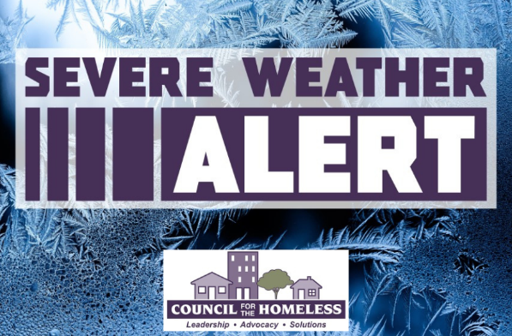

Severe Weather Alert for
Friday, March 13, 2026 to
Saturday, March 14, 2026

Clark County, Wash. (March 12, 2026) — Council for the Homeless is issuing a Severe Weather Alert for Friday and Saturday, March 13-14, 2026 due to significant rainfall and flooding.

Additional resources and increased shelter capacity will be activated during this time period.

A message from our friends at C-TRAN:

"During extreme weather events, C-TRAN will not turn anyone away who is riding to a warming center. Passengers should tell the operator as they board that they’re heading to a warming center, and fares will not be enforced."

﻿Community Shelter Center Maps:

CRESA: https://www.google.com/maps/d/viewer?mid=1kBdSaFSvF4FdiRkzDxA6rpGz-l9FPPE&ll=-3.81666561775622e-14%2C-122.54998275000001&z=1﻿

Please direct people who need shelter and housing assistance to the Council for the Homeless Housing Hotline at (360) 695-9677. The Housing Hotline is open Monday-Friday from 9:00 AM to 8:00 PM and on weekends and holidays from 11:00 AM to 5:00 PM.

Follow CFTH Social Media for new information and timely updates.

