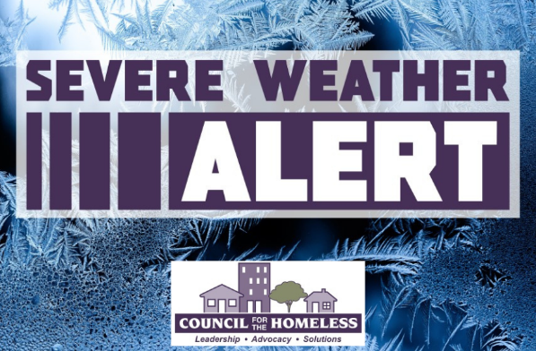
Severe Weather Alert
Sunday through Sunday
February 10-12, 2026

Clark County, Wash. (February 10, 2026) — Council for the Homeless is issuing a Severe Weather Alert for the emergency shelter system in Clark County, for February 10 through February 12 due to cold temperatures.

Additional resources and increased shelter capacity will be activated during this time period.
Overnight Warming Centers:

Living Hope Church
Nights open: Wednesday, Feb. 11 & Thursday, Feb. 12
Hours: 7:00 PM - 7:00 AM
Address: 2711 NE Andresen Rd; Vancouver, WA 98661
Nearest C-Tran: #32 or Fourth Plain Vine

A message from our friends at C-TRAN:

"During extreme cold temperatures, C-TRAN will not turn anyone away who is riding to a warming center. Passengers should tell the operator as they board that they’re heading to a warming center, and fares will not be enforced."

﻿Community Shelter Center Maps:
CRESA: https://www.google.com/maps/d/viewer?mid=1kBdSaFSvF4FdiRkzDxA6rpGz-l9FPPE&ll=-3.81666561775622e-14%2C-122.54998275000001&z=1﻿

Please direct people who need shelter and housing assistance to the Council for the Homeless Housing Hotline at (360) 695-9677. The Housing Hotline is open Monday-Friday from 9:00 AM to 8:00 PM and on weekends and holidays from 11:00 AM to 5:00 PM. Follow CFTH social media for new information and timely updates.

