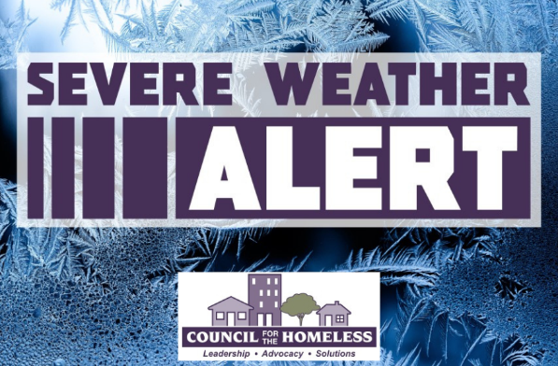
Severe Weather Alert
Sunday through Monday
January 18-19, 2026

Clark County, Wash. (January 16, 2026) — Council for the Homeless is issuing a Severe Weather Alert for the emergency shelter system in Clark County, for January 18 through January 19 due to cold temperatures beginning Sunday through Monday. Additional resources and increased shelter capacity will be activated during this time period.
Overnight Warming Centers:

Living Hope Church
Days open: Sunday, Jan. 18 & Monday, Jan. 19
Hours: 7:00 PM - 7:00 AM
Address: 2711 NE Andresen Rd; Vancouver, WA 98661
Nearest C-Tran: #32 or Fourth Plain Vine

Daytime Warming Centers:

St. Paul's Lutheran Church
Days open: Monday-Friday, Jan. 18-23
Hours: 9:00 AM – 3:00 PM
Address: 1309 Franklin St., Vancouver, WA 98660 (enter off 13th street, down concrete stairs, located on the east corner of the main church building)
Other information: well-behaved, leashed pets are welcome
Bus Lines:
#25 southbound stops on Franklin between 13th and 14th, on the west side of SPLC
#25 eastbound stops on Franklin at Mill Plain. Walk 2 blocks south to 13th, and turn left to the indicated church stairway.
#2, #30, #32, #41, #71, #105 and Fourth Plain (green) Vine drive on Washington and stop at 13th Street; Washington is 3 blocks west of Franklin.

A message from our friends at C-TRAN:

"During extreme cold temperatures, C-TRAN will not turn anyone away who is riding to a warming center. Passengers should tell the operator as they board that they’re heading to a warming center, and fares will not be enforced."

﻿Community Shelter Center Maps:

CRESA: ttps://www.google.com/maps/d/viewer?mid=1kBdSaFSvF4FdiRkzDxA6rpGz-l9FPPE&ll=-3.81666561775622e-14%2C-122.54998275000001&z=1﻿

Please direct people who need shelter and housing assistance to the Council for the Homeless Housing Hotline at (360) 695-9677, open Monday-Friday from 9:00 AM to 8:00 PM and on weekends and holidays from 11:00 AM to 5:00 PM.

Follow CFTH Social Media for new information and timely updates.

