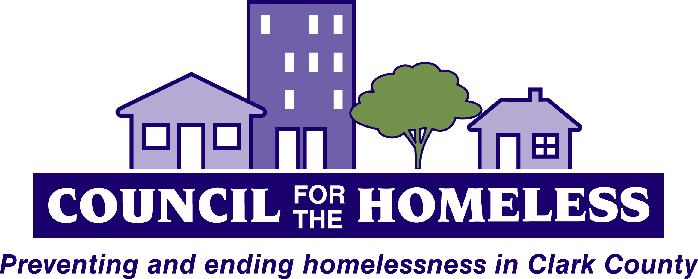

Coalition of Service Providers for the Homeless
--A Continuum of Care and Homeless Task Force
Wednesday March 13, 2013
10:00am - 12:00pm

YWCA Community Room, 3609 Main St. Vancouver

AGENDA

10:00 Welcome Andy Silver

10:10 Introductions and Announcements All

10:20 Issues, Hot Topics, Discussion
- WA Connections Portal Kirby Juhola
- Ways to Work Program Abby Wood
- Comcast internet access program and Jack Burkman
City of Vancouver reading program
- Housing Solutions Center launch Andy Silver

11:35 Work Group Reports:
Work group reorganization Andy Silver
- 10-Year Planning Pete Munroe
- Youth Access Chelsea Jackson
- Discharge Planning and Prevention Kate Budd
- Data Management/Housing Inventory Dale Whitley

12:00 Adjourn

Next meeting: May 8, 2013, 10am-Noon
YWCA 3609 Main Street, Vancouver WA 98663

The Coalition meets on the 2nd Wednesday bi-monthly for
community planning to prevent and end homelessness in Clark County.

Contact: Council for the Homeless (360) 993-9570 or asilver@councilforthehomeless.org
For more information on the Coalition, visit www.councilforthehomeless.org and click on Agency Resources.

Individuals attending this meeting may have serious medical sensitivities to perfumes, colognes, scented lotions, aerosols, cleaning products, and scent-producing items, such as glue, markers, and scented candles. We ask that you respect their needs by voluntarily refraining from wearing or using scented products during the meeting. Thank you.

SAVE THE DATE: The 23rd annual Washington State Conference on Ending Homelessness is May 15 and 16 in Tacoma.
Go to http://wliha.org/conference for details.

