**FOCUS OF WORK**

**Poverty/Economics**

**Collective Impact Focus**lessness

**COC Decisions**

**Housing and**

**Homelessness System**

**COC STEERING COMMITTEE:**

**COC HUD Funded Decisions and Oversight**

The purpose of the Continuum of Care Steering Committee (CoC SC) is to submit an annual

application to the US Department of Housing and Urban Development (HUD) for local homeless

housing projects and to evaluate ongoing progress in meeting CoC goals.

**Collective Impact Focus**

Embedded in the collective impact framework is the notion of working collectively, often across multiple sectors, on a common issue.

• A framing tool for collaborative efforts

• An opportunity to get partners on the same page

• Shared agreement on the process and outcome measures that lead to change

• Agreement on the activities that move the needle on outcomes

• Recognition of the value of resources to drive forward change

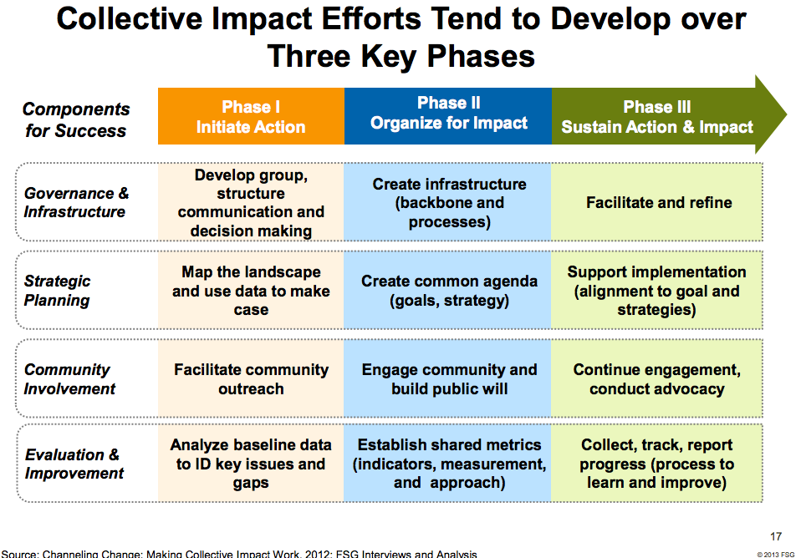

**COLLABORATIVE ACTION**

Based upon data, community engagement and program outcomes the COC Steering Committee will initiate collaborative action to solve problems and reduce barriers around housing and homelessness.

**Agreed on areas of collective focus:**

1. ***Client Rental Accessibility***

There is a consistent pattern of clients who are not securing places to rent even though they have been approved for one of our rapid re-housing programs. We have also observed that many of the clients we are placing into these programs have barriers to obtaining to rental. These barriers include past evictions, monies owed to previous landlords, criminal histories and a lack of income.

**Goal: Develop a strategy to increase the amount of landlords willing to rent to our Rapid Re-housing clients.**