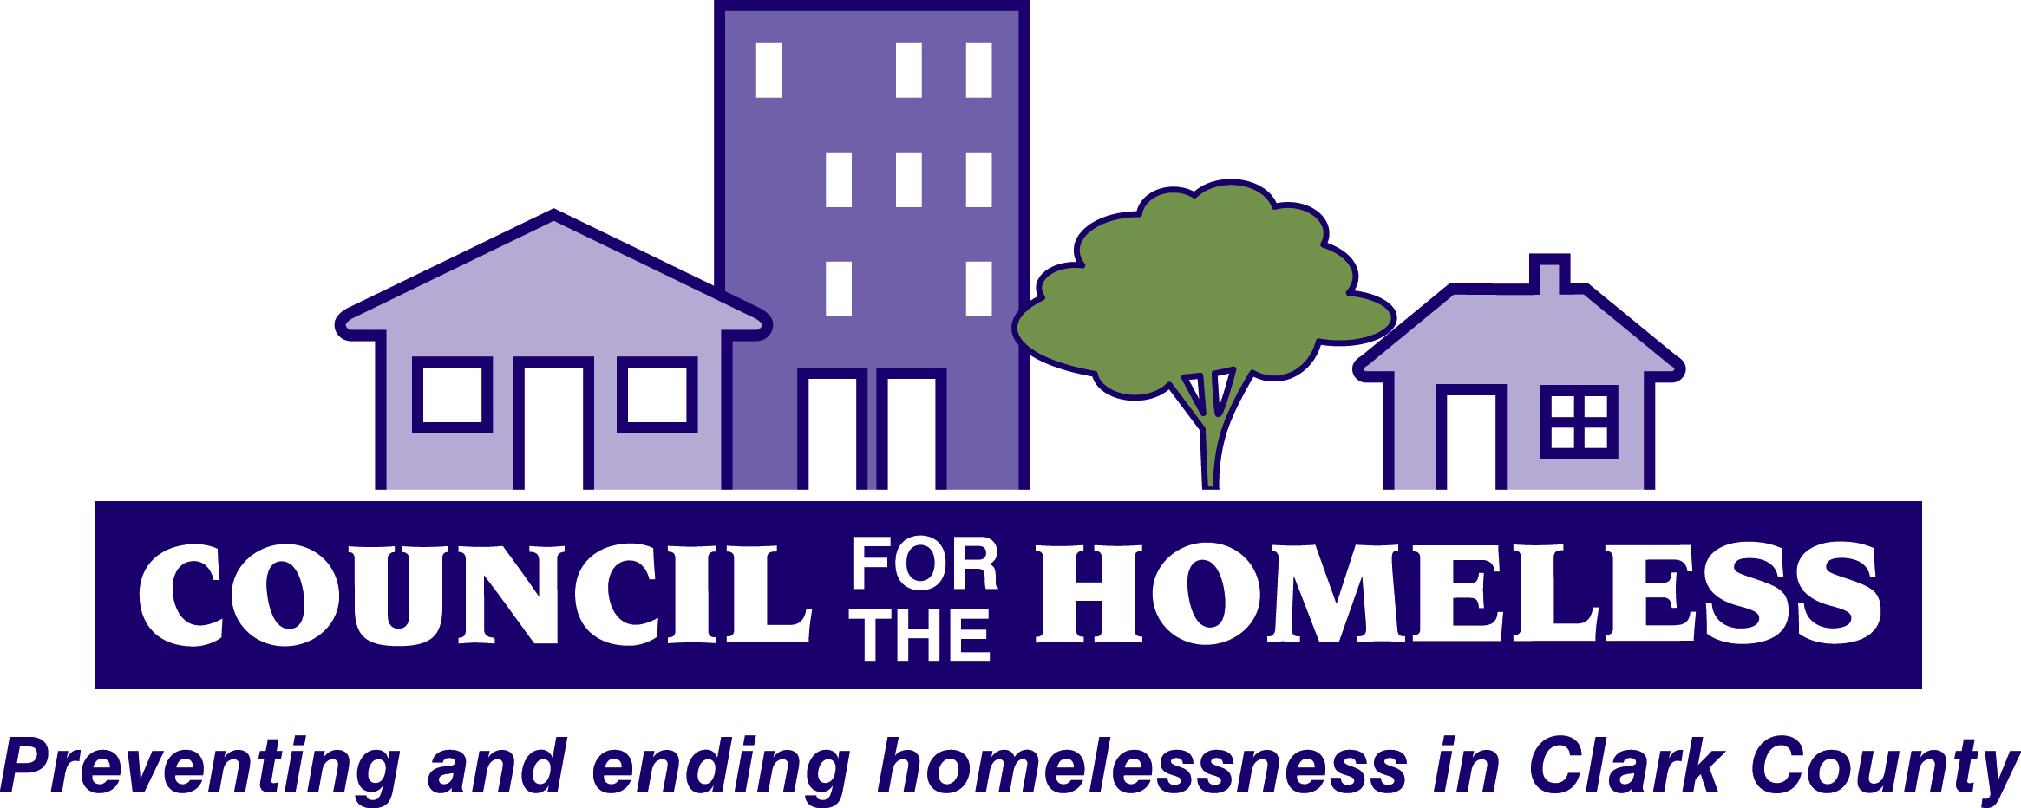

Clark County/City of Vancouver Continuum of Care Background and Instructions for FY2016 Grant Application Process

Table of Contents

Introduction Page 3

Continuum of Care Overview Page 3

Application Process Overview Page 5

Application Process Details/Important Dates Page 5

What Would Cause a New Project Application to be rejected? Page 6

What would Cause a Renewal Project Application to be rejected? Page 6

If a Project is accepted through the Local RFA is it guaranteed funding? Page 6

2016 New Project Scoring Criteria Page 7

Introduction

The Council for the Homeless (CFTH), the lead agency for the Clark County/City of Vancouver Continuum of Care (CoC)-also known as the Coalition of Service Providers- coordinates the process to submit the annual consolidated application for U.S. Department of Housing and Urban Development’s (HUD) CoC Homeless Assistance Program funding.

Annually, HUD releases a Notice of Funding Availability (NOFA) for federal funding for CoC Homeless Assistance Programs funding. It is a collaborative application process – each CoC submits both a Consolidated Application – a community profile of homeless housing and services, a community action plan and each of the programs submit individual Project Applications from the CoC. All programs must submit their application through their local CoC – HUD will not review any applications that are submitted independent from a CoC.

We have a local application process (outlined in this document) to determine which currently-funded projects the community will include in our application for renewal; which new applicants will be included; and how each project is prioritized in case HUD does not fund all the projects.

This document outlines the local application process and how it relates to the submission of the consolidated application to HUD for CoC funding. It also includes the instructions for how to complete this year’s local application process.

All information and forms pertaining to the process are available on the CFTH website on the FY2016 CoC 2016 Application page. www.councilforthehomeless.org.

Continuum of Care Overview
The CoC model was adopted by HUD in 1994 giving local communities the charge to form a primary planning and coordinating body, known as CoCs, for homeless housing and services to work toward the goal of ending homelessness. The regulations clearly define the primary responsibilities of the CoC as follows:
(a) Operate the Continuum of Care. The Continuum of Care must:
(1) Hold meetings of the full membership, with published agendas, at least semi-annually;
(2) Develop an invitation process for new members to join publicly available within the geographic at least annually;
(3) Adopt and follow a written process to select a board to act on behalf of the Continuum of Care. The process must be reviewed, updated, and approved by the Continuum at least once every 5 years;
(4) Appoint additional committees, subcommittees, or workgroups;
(5) In consultation with the collaborative applicant and the HMIS Lead, develop, follow, and update annually a governance charter, which will include all procedures and policies needed to comply with subpart B of this part and with HMIS requirements as prescribed by HUD; and a code of conduct and recusal process for the board, its chair(s), and any person acting on behalf of the board;
(6) Consult with recipients and sub-recipients to establish performance targets appropriate for population and program type, monitor recipient and sub-recipient performance, evaluate outcomes, and take action against poor performers;
(7) Evaluate outcomes of projects funded under the Emergency Solutions Grants program and the Continuum of Care program, and report to HUD;
(8) In consultation with recipients of Emergency Solutions Grants program funds within the geographic area, establish and operate either a centralized or coordinated assessment system that provides an initial, comprehensive assessment of the needs of individuals and families for housing and services. The Continuum must develop a specific policy to guide the operation of the centralized or coordinated assessment system on how its system will address the needs of individuals and families who are fleeing, or attempting to flee, domestic violence, dating violence, sexual assault, or stalking, but who are seeking shelter or services from non-victim service providers. This system must comply with any requirements established by HUD by Notice.

(9) In consultation with recipients of Emergency Solutions Grants program funds within the geographic area, establish and consistently follow written standards for providing Continuum of Care assistance. At a minimum, these written standards must include:
(i) Policies and procedures for evaluating individuals and families eligibility for assistance under this part;
(ii) Policies and procedures for determining and prioritizing which eligible individuals and families will receive transitional housing assistance;
(iii) Policies and procedures for determining and prioritizing which eligible individuals and families will receive rapid rehousing assistance;
(iv) Standards for determining what percentage or amount of rent each program participant must pay while receiving rapid rehousing assistance;
(v) Policies and procedures for determining and prioritizing which eligible individuals and families will receive permanent supportive housing assistance; and
(vi) Where the Continuum is designated a high-performing community, as described in subpart G of this part, policies and procedures set forth in 24 CFR 576.400(e)(3)(vi), (e)(3)(vii), (e)(3)(viii), and (e)(3)(ix).

(b) Designating and operating an HMIS. The Continuum of Care must:
(1) Designate a single Homeless Management Information System (HMIS) for the geographic area;
(2) Designate an eligible applicant to manage the Continuum‘s HMIS, which will be known as the HMIS Lead;
(3) Review, revise, and approve a privacy plan, security plan, and data quality plan for the HMIS.
(4) Ensure consistent participation of recipients and sub-recipients in the HMIS; and
(5) Ensure the HMIS is administered in compliance with requirements prescribed by HUD.

(c) Continuum of Care planning. The Continuum must develop a plan that includes:
(1) Coordinating the implementation of a housing and service system within its geographic area that meets the needs of the homeless individuals (including unaccompanied youth) and families. At a minimum, such system encompasses the following:
(i) Outreach, engagement, and assessment;
(ii) Shelter, housing, and supportive services;
(iii) Prevention strategies.
(2) Planning for and conducting, at least biennially, a point-in-time count of homeless persons within the geographic area that meets the following requirements:
(i) Homeless persons who are living in a place not designed or ordinarily used as a regular sleeping accommodation for humans must be counted as unsheltered homeless persons.
(ii) Persons living in emergency shelters and transitional housing projects must be counted as sheltered homeless persons.
(iii) Other requirements established by HUD by Notice.
(3) Conducting an annual gaps analysis of the homeless needs and services available within the geographic area;
(4) Providing information required to complete the Consolidated Plan(s) within the Continuum‘s geographic area;
(5) Consulting with State and local government Emergency Solutions Grants program recipients within the Continuum‘s geographic area on the plan for allocating Emergency Solutions Grants program funds and reporting on and evaluating the performance of Emergency Solutions Grants program recipients and sub-recipients.

Application Process Overview

The HUD Notice of Funding Availability (NOFA) provides the process and requirements for the submission of the 2016 HUD Project Application. It is imperative that all new and renewal applicants read the NOFA and accompanying guidance from HUD. The Project Applications are done electronically through the e-snaps system. It is the responsibility of each project applicant to get their information entered into e-snaps by the deadlines outlined below. Once all individual project applications are entered into e-snaps they are linked to the Clark County/City of Vancouver Consolidated Application and accepted applications are submitted by the Council for the Homeless as one entire submission package to HUD.

All renewal projects are monitored, scored and ranked by the CoC Program Monitoring and Scoring Subcommittee in a process outlined in the “Vancouver/Clark County CoC Programs Monitoring Policies and Procedures.” Renewal applicants must also complete their project applications in e-snaps by the dates listed below. These project applications will be reviewed for technical sufficiency as well as adherence to the policy goals outlined in the NOFA (housing first, prioritizing chronic homelessness, etc.).

This year’s NOFA includes Permanent Housing Bonus funds. We are accepting new applications for up to $78,345 for Permanent Housing Bonus permanent supportive housing projects that serve chronically homeless households utilizing a housing first approach (the amount available may increase if any renewal projects are reallocated as a result of the monitoring process). These new applications must be completed in e-snaps by the dates listed below and must adhere to the rules for Permanent Housing Bonus funds outlined in the NOFA. If a project application meets the requirements of the NOFA and of these guidelines it will be scored and ranked against other new projects. All new projects will be ranked below renewal projects in the overall submission package to HUD.

Application Process Details/Important Dates

- On July 26th, the CoC will release a request for applications (RFA) for new permanent supportive housing projects. CFTH will email the RFA to the CoC listserv and post it on the CFTH website (www.councilforthehomeless.org).

- Between July 26th and August 9th, Andy Silver (Executive Director of the Council for the Homeless) will be available to organizations that want more information or have questions about the RFA or any part of the process. Andy can be reached by email at asilver@councilforthehomeless.org or by phone at 360-993-9570.

- All new and renewal applications must be submitted electronically in the e-snaps system by August 9th at 5pm. Failure to submit an application by the deadline may result in disqualification from the competition.

- The Council for the Homeless will review all applications for technical sufficiency. The Monitoring and Scoring Sub-Committee of the CoC Steering Committee will read all new applications that are technically sufficient and score each project based on the scoring matrix, which is included in this document.

- On August 31st, the CoC Steering Committee will approve the final project listing and prioritization and shortly thereafter, projects will be notified, and the final version will be posted on the CFTH website.

What Would Cause a New Project Application to be rejected?

The CoC is only accepting new project applications this year for permanent supportive housing programs that serve people who are chronically homeless using the housing first model. Any new application that proposes a different housing type (transitional housing, emergency shelter, rapid re-housing) will be rejected. Any new application that proposes to serve a population broader than HUD’s definition of chronically homeless will be rejected. Any new project that does not plan on implementing a housing first model will be rejected. Applicants must read the requirements for Permanent Housing Bonus projects in the FY2016 NOFA carefully; if their application does not meet all requirements it will be rejected.

Finally, all new projects will be scored according to the scoring criteria listed in this document. The highest scoring project(s) will be funded based on amount available. New projects that score below the funding line will be rejected.

What would Cause a Renewal Project Application to be rejected?

A renewal project can be rejected and reallocated through the monitoring process according to the process set forth in the monitoring policies and procedures. Renewal applications must also Sbe completed in e-snaps and meet the requirements laid out in the NOFA and these guidelines. Renewal projects that do not meet the requirements in the NOFA or these guidelines will be rejected.

If a Project is accepted through the Local RFA,
is it guaranteed funding?

No. New and Renewal projects selected through our local RFA process will be included in the community application to HUD. Individual projects may still be rejected by HUD for not meeting HUD’s technical sufficiency requirements. Also, individual projects may not be funded by HUD due to lack of HUD funds and their position on our prioritization list.

2016 New Project Scoring Criteria
Total Maximum Score = 50 pts

 | Project Description and Narrative | Application Accuracy | Budget and Fiscal Information
Benchmark  Scoring  Factors | -Project adherence to the housing first model (closer to a true model the more points scored) (10 points)  - Services are appropriate for the type of project and target population proposed (5 points)  -Organizational experience/capacity to do work (5 points)  -If target population is limited, then evidence that there is community need for such limitation (5 points)  -Referral process/how people will access services (use of coordinated assessment, type of assessment used) (5 points)  -Readiness to proceed with project (5 points) | - Correctly filled out project application (Only serving eligible participants, 100% chronic homeless, housing first model, meets NOFA requirements, etc.) (5 points) | -Budget is accurate and reasonable (5 points)
Data Source | Project Application  2B, 3B, 4A, 5 | Project Application | Project Application  6
Potential Points by Criteria | 40 points | 5 points | 5 points

