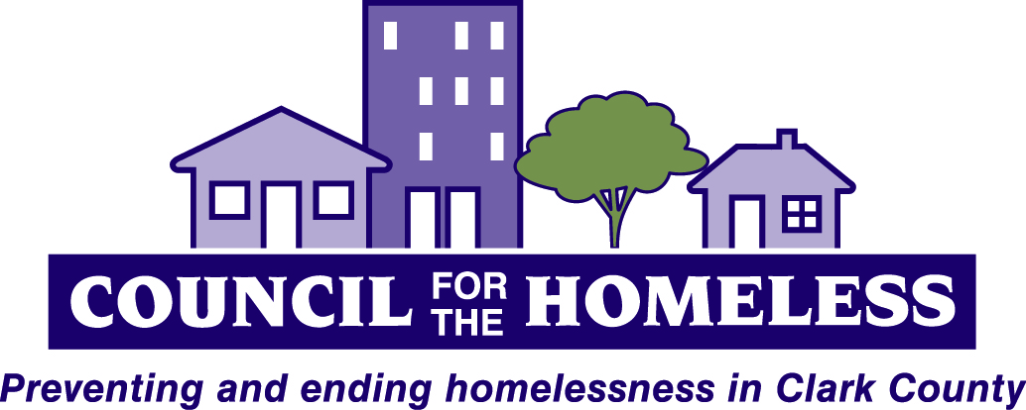

Coalition of Service Providers for the Homeless
--A Continuum of Care and Homeless Task Force
Wednesday, January 13
10:00am-11:30am

YWCA Community Room, 3609 Main St. Vancouver

AGENDA

10:00 Welcome Andy Silver

10:05 Introductions and Announcements All

10:10 Issues, Hot Topics, Discussion

    - Project Homeless Connect and Point in Time Count Dale Whitley
David Bilby
- Update on Early Adopter Vanessa Gaston
- Presentation on Adverse Childhood Experiences Cyndie Meyer
- State and Local Advocacy Update Andy Silver
- Clark County 2016 Funded Programs (Breakout Activity) Kate Budd

11:10 CoC Steering Committee Amy Reynolds
11:15 Work Group Reports

      - Data Quality Dale Whitley
      - Coordinated Assessment Work Group Olivia Resnick
      - Housing First Cohort Olivia Resnick
      - Bridges to Employment Task Force Kate Budd
      - Youth Task Force Scott Conger

11:30 Adjourn

Next Meeting: January 13, 10:00-11:30am
YWCA 3609 Main Street, Vancouver WA 98663

The Coalition meets on the 2nd Wednesday bi-monthly for
planning to prevent and end homelessness in Clark County.

Contact: Council for the Homeless (360) 993-9561 or asilver@councilforthehomeless.org
For more information on the Coalition, visit www.councilforthehomeless.org and click on Agency Resources.

Individuals attending this meeting may have serious medical sensitivities to perfumes, colognes, scented lotions, aerosols, cleaning products, and scent-producing items, such as glue, markers, and scented candles. We ask that you respect their needs by voluntarily refraining from wearing or using scented products during the meeting. Thank you.

